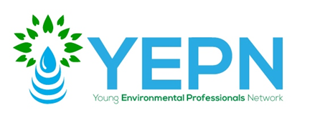
You are invited

Emerging Risk of PFAS Substances Roundtable
April 4, 2018
5:30-6:30 p.m. Networking
6:30-7:30 p.m. Roundtable

Chubb USA
436 Walnut Street
Philadelphia, PA 19106
Please join us for a technical introduction to the emerging contaminant from an environmental consulting perspective and discuss regulatory challenges, current litigation, and ways in which the insurance industry is responding. Our networking happy hour will include complimentary food and drinks.
RSVP

Moderator:
Candee Wilde, Esq.
Greenberg Traurig, LLP

Panelists:

Kaitlyn R. Maxwell, Esq. practices in the environmental group of Greenberg Traurig, LLP. Her principal office is in Philadelphia. She focuses her practice on environmental litigation. Ms. Maxwell advises clients on regulatory compliance issues and represents clients in litigation in state and federal courts. Her work includes litigation of major contamination cases under the hazardous waste and Superfund laws. She also advises clients in transactions involving the sale of contaminated real property.

BobbiAnn Murphy is a consultant at Antea Group with over ten years of experience in various aspects of the environmental consulting industry. Her expertise includes insurance claim investigation, regulatory guidance and interpretation, environmental liability management, environmental liability transfers, site characterization, remedial feasibility studies and implementation, environmental due diligence assessments, regulatory agency negotiations and strategizing, litigation support, and environmental compliance assessments.

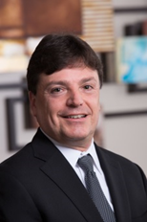
Steve Piatkowski, Senior Vice President, Chubb Environmental, based in Philadelphia, PA has both national and international responsibility for the technical evaluation of risks for all of the company’s environmental insurance lines. With a strong underwriting background, Steve also supports the various business units in developing policy pricing, terms, and conditions based on engineering data available. In addition, Steve also serves as the technical liaison between Chubb Environmental claims and Chubb Environmental underwriting, as well as manages Chubb Environmental’ s North American and international underwriting audit programs.
About YEPN I Philadelphia is one of the most environmentally sustainable and conscious cities in the United States. In the public sphere, we boast excellent water management and infrastructure, innovative programs to reduce carbon emissions, and a strong Office of Sustainability working on all aspects of city sustainability. In the private and state government sectors, we have environmental researchers at our universities, environmental consulting and remediation firms, environmental lawyers, the EPA Region 3 headquarters, and many others. The Young Environmental Professionals Network of Philadelphia seeks to connect these passionate professionals.

