You are invited
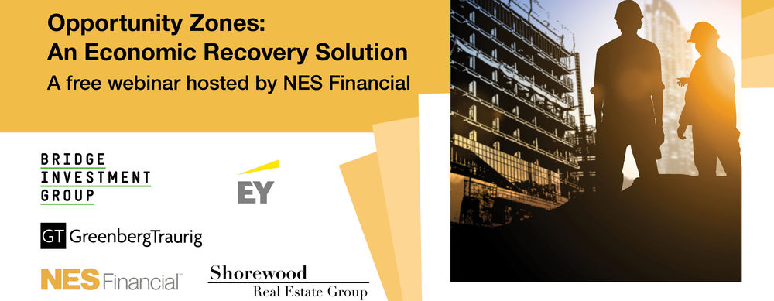
Thursday, May 14, 2020
2:00 PM EST / 11:00 AM PST
Register Here Now

The Opportunity Zones initiative stands perfectly at the confluence of three recent nationwide developments:

- a market selloff, which has generated an unprecedented amount of capital gains;
- a reset in the real estate cycle;
- heightened social awareness among investors.

As a result, Opportunity Zones may be instrumental in efforts to rebuild the U.S. economy. And Opportunity Zone funds with the right projects and social impact priorities stand to do the most good, while also gaining market share.

Join us for this free webinar, in which we’ll discuss:
- Marketing to “impact investors”
- Which areas/project types will be favored in the new economy?
- OZ as a platform for equitable recovery
- Regulatory update: e.g.; how will federal disaster declarations affect working capital safe harbor allowances for OZ Funds?
- OZ market data through the first quarter of 2020 (and emerging trends)

Speakers include:
- Reid Thomas, Executive Vice President. NES Financial
- S. Lawrence Davis, President and CEO, Shorewood Real Estate Group
- Jim Lang, Shareholder, Greenberg Traurig
- Michael Bernier, Partner, Ernst & Young
- David Coelho, Chief Strategy Officer, Chief Investment Officer – Opportunity Zone Program, Bridge Investment Group

Take advantage of these experts’ insights. Reserve your place today.
Greenberg Traurig, LLP | Attorneys at Law | www.gtlaw.com

