You are Invited
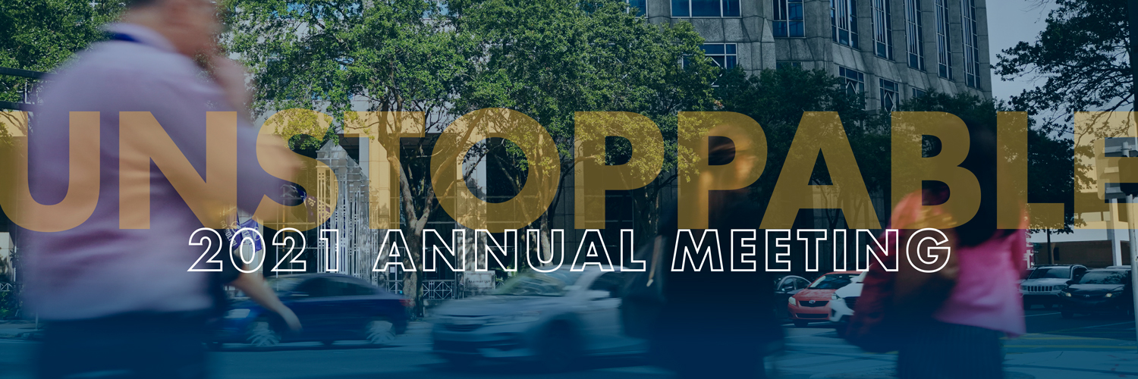
Tampa Bay Economic Development Council
Annual Meeting

Wednesday, November 3, 2021
4:00 - 7:00 pm

J.W. Marriott – Water Street
510 Water Street, Tampa, FL 33602

A must-attend event for business and community leaders, the Tampa Bay EDC’s 2021 Annual Meeting is set for Wednesday, November 3, at 4 p.m. at the JW Marriott Water Street Tampa. This signature event looks back at the past fiscal year’s biggest achievements of both the Tampa Bay EDC, their Investors and partners. Despite the ongoing challenges of the pandemic, the Tampa Bay community has proven to be UNSTOPPABLE. This is a very fitting theme for this year’s annual meeting as it personifies the incredible momentum the Tampa Bay business community is experiencing right now.

RSVP

Greenberg Traurig, PA | Attorneys at Law | www.gtlaw.com

