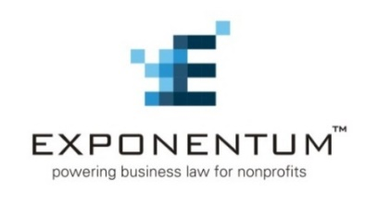

Virtual Pro Bono Clinic: National Day of Service
Corporate Governance Check-up for Nonprofits

Nonprofit organizations face a long list of regulatory and other legal burdens, making it a challenge to assess their governance and fiscal oversight procedures while also doing the day-to-day work to meet their mission. To support our nonprofit clients who are working tirelessly to strengthen underserved communities during challenging times, Bay Area Legal Services, Inc., through the Judge Don Castor Community Law Center, and Exponentum™ are teaming up to provide a pro bono assessment of corporate governance practices, structure, and documents.

The Judge Don Castor Community Law Center is seeking Florida volunteer attorneys to help with this National Day of Service. Participating attorneys will meet in virtual Zoom rooms to review our Corporate Governance Assessment Tool and provide related advice to participating nonprofit organizations.

Before the Virtual Pro Bono Clinic, each registered volunteer attorney will be emailed a link to a pre-recorded webinar, along with the assessment tool created by Exponentum™, which will serve as a guide in the private consultations. A brief orientation will be held at 4:30PM for volunteer attorneys. The participating nonprofit organizations will join the meeting at 5:00PM.

This is a limited scope pro bono clinic: attorneys will not be required to do pro bono work for the assigned client after the clinic.

DATE/TIME: Wednesday, January 26, 2022, 4:30PM to 6:30pm
LOCATION: Virtual conference room information to be provided to registered volunteers

TO RSVP: Fill out the form below, save the file, and e-mail it to Susan Sandler, Project Director, Judge Don Castor Community Law Center (ssandler@bals.org) no later than January 17, 2021.

Attorney’s Name: ____________________________________________________________

Attorney’s Title: _____________________________________________________________

Corporation or Firm: __________________________________________________________

Attorney’s Work Address: ______________________________________________________

Attorney’s Telephone No.: _____________________________________________________

Florida Bar No.: ______________________________________________________________

Legal Practice area(s): ________________________________________________________

Other comments (if any): _____________________________________________________

Exponentum™, www.expondentum.org is a collaboration of pro bono providers that serve geographic regions throughout the United States. Exponentum is dedicated to improving the quality of life in low-income and disadvantaged communities by expanding the availability and quality of pro bono business legal services for nonprofits that serve those communities. Exponentum partners with law firms and corporations to implement national responses to challenges faced by the nonprofit sector by delivering expert legal assistance and educational programs to nonprofits.

