
You are Invited

WISDOM
Pearls of
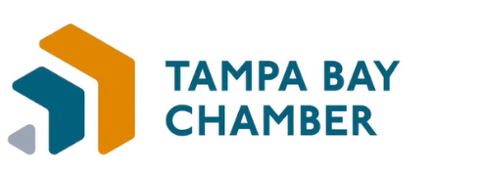
National Pro Bono Week Luncheon

Women in Tech - Pearls of Wisdom Luncheon
Tuesday, March 8, 2022
11:30 am – 1:30 pm
Rusty Pelican
2425 N. Rocky Point Drive
Tampa, FL 33607

Please join us for an informative presentation and luncheon. This luncheon focuses on Women in Tampa’s burgeoning tech scene. Today’s speaker, Carolyn Eagen, Founder and CEO of Kinstak headquartered in Tampa, developed this private cloud storage company for military members and their families. Her background is in GTM strategy, cloud technologies, data and analytics, data visualization, and data storytelling. Her passion for Kinstak stemmed from her family experiences of being adopted and her mother’s unexpected passing away at 24 years old.

The lack of an easy way to store and organize her family’s digital legacy has driven her and Kinstak’s all-star technical team to build a simple way to store and automatically organize family files and photos into a private digital legacy solution. She has over 20 years of professional experience in leading top-performing teams globally with award-winning-record-breaking results.

Kinstak has been selected and is currently participating in the National Science Foundations I-Corp Program and has since launched their first version released to a cohort of military members and their families for feedback and next-generation product development. Kinstak’s next launch is planned for the Summer of 2022 near strategic military bases for military members and their families located in Florida, North Carolina, Virginia, and California.

Kinstak has received attention and recognition from these Start-Up Accelerators & National Programs:

- NSF (National Science Foundation) I-Corp Program – FAU Fort Lauderdale, FL
- Subscription Summit Semi-Finalist 2022 – SUBTA Orlando, FL
- Tech Women Rising, Tampa Bay WAVE- Tampa, FL
- The Venture City – Miami, FL
- Zane Access – Capital Readiness Program – Atlanta, GA
- Top Innovator – Young Start-Up Ventures Top 100 – Global
- Y Combinator Start-Up School Certified – Mountain View, CA
- USF Advisory Board Member – Customer Experience Program

RSVP

Greenberg Traurig, PA | Attorneys at Law | www.gtlaw.com

