Save the date
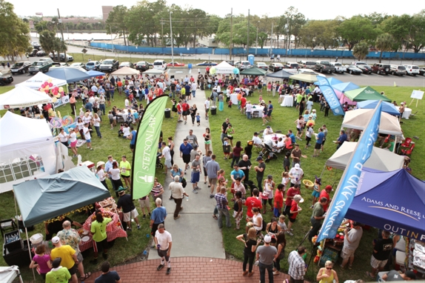
Hillsborough County Bar Association Pro Bono 5K Run and Judicial Food Festival
Plan to join us for the HCBA Judicial Food Festival & 5K Pro Bono Run on March 26. The 5K run will begin at 10:00 a.m. starting at Water Works Park near the Chester H. Ferguson Law Center. The race course is along Tampa's beautiful River Walk.
After the race, please join your friends and colleagues from the local legal community at the HCBA's annual Judicial Food Festival on the grounds of the Stetson Law Tampa Campus. The Judicial Food Festival will take place from 11:00 a.m. to 2 p.m. Greenberg Traurig will have a food tent. Please make sure to visit us.
Saturday, March 26, 2022
10:00 a.m. – 2:00 p.m.
Stetson Law Tampa Campus
1700 N. Tampa Street
Tampa, FL 33602

Agenda:
10:00 a.m. – 11:00 a.m.
Pro Bono 5K
11:00 a.m. – 2:00 p.m.
Judicial Food Festival

Greenberg Traurig, PA | Attorneys at Law | www.gtlaw.com

