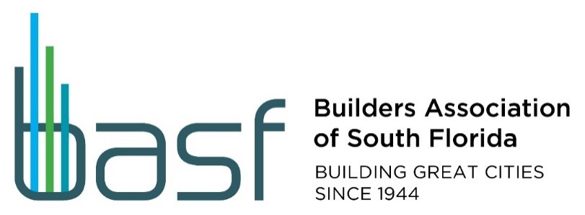

**Miami-Dade County Legislative Committee**

**8:30 am – 9:30 am – Friday, June 16, 2023**

**Greenberg, Traurig, 333 SE Second Ave, 44th floor, Miami 33131**

**Or:**

**Via Zoom link:**

Join Zoom Meeting

<https://us02web.zoom.us/j/3277820389>

Meeting ID: 327 782 0389

**8:30 am Sharp!**

**Special Guests from the City of Miami:**

**Planning Director, Lakisha Hull, AICP**

**And**

**Zoning Administrator, Daniel S. Goldberg, Esq.**

**Topic:**

**Streamlining efforts to Planning and Zoning Process**

**______________ Agenda! __________________**

1. **Welcome and Introductions** – **Chairman Joe Goldstein, Esq; Vice-Chairman Brian Adler, Esq.**
2. **8:30 am – 8:50 am -** 
   1. **Guest Speakers: Lakisha Hull and Daniel Goldberg -** 
      1. Planning and Zoning Updates on pending and future legislation
      2. Waiver ordinances – overview of several items
         1. PZAB hearing held – results of meeting
      3. Discussion and Q and A Session.
   2. **Process Improvements Meeting held last Friday, June 9th, 2023 with Deputy City Manager and Senior staff –** report by participating members and staff
   3. **City of Miami’s Affordable Housing Act Forum held – Thursday, June 15th, 2023** 
      1. Report by City staff and participating members.
   4. **Upcoming issues and working together with Industry.**
3. **City of North Miami – BASF held two meetings with City Manager –** 
   1. **Reduced major fee increase**; correcting resolution adopted at June 13, 2023 public hearing for July 1, 2023 effective date;
   2. **Still of concern:** percentage credit for projects using private provider - Report by participating members and staff – members to continue meeting with staff to finalize percentage credit on building permit.

**Continued on page 2**

**Pending Legislation of interest:**

1. **Mobility Fee – went to May 16, 2023, BCC** for first reading – Similar to roadway impact fee price points but based on different formulas; will permit County spending on other mobility modes: pedestrian, bicycle, and transit, not just roads.
2. **Upcoming issue:** Proposed CDMP amendment to revise residential supply formula by MSA vs. county-wide capacity –working group assembled.
3. **Recently adopted Legislation:** 
   1. **Construction Noise Ordinance –** Much preferred Substitute Ordinance adopted by County Commission on 5-2-23 - by Steinberg. Effective on May 12, 2023, Legis No. 230780 - Participating members and staff to report.
   2. **Septic Tank exception legislation now in effect Ordinance No. 23-26 –** for few outstanding building permits – update by staff.
4. **DERM Working Group Meetings – update by participating members and staff**
   1. **Soil Re-Use Guidance letter – meeting with DERM staff held on May 31, 2023**
      1. Participating members and staff to report
   2. **Next Quarterly meeting: Monday, August 14, 2023:** 
      1. Plan Review Issues Agenda: 9:00 am – 10:15 or sooner if completed.
      2. Legal/Environmental Agenda – 10:30 am – 12:00 Noon – or sooner if completed.
5. **WASD-BASF Meeting held –** update by participating members and staff
6. **Summer Break for Legislative Meetings!** 
   1. **Next meeting:** Friday, August 18, 2023 – Watch your email for information about downtown location.
7. **Announcements and adjourn.**

J,\\11.10\

