
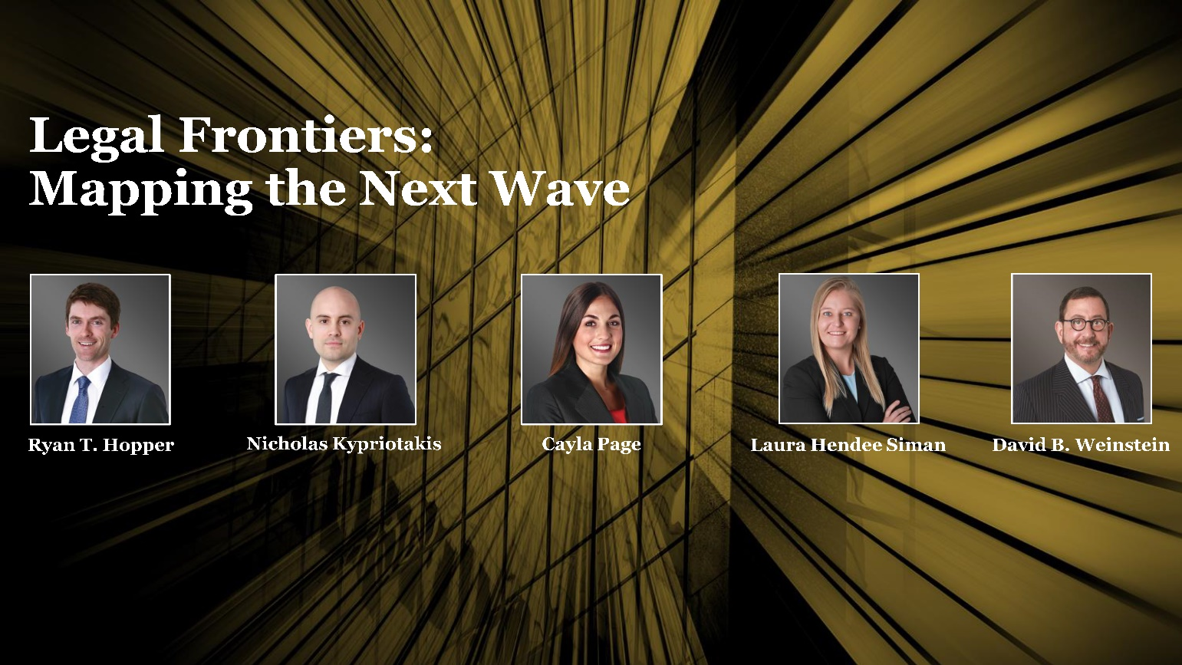 | You are invited
Please join us for a CLE Luncheon
Thursday, February 29, 2024
11:30 am Registration & Networking
12:00 – 1:00 pm Program
The Tampa Club
101 E. Kennedy Blvd., Suite 4100
Tampa, Florida 33602

Chief legal officers, general counsel, and senior legal leaders face an increasingly challenging business marketplace. Understanding the legal trends makes requirements to mitigate vulnerabilities, maintain compliance, and capitalize on opportunities an easier task. Challenges (or opportunities) of technology advances, geopolitical and economic volatility, regulatory uncertainty, and workforce disruptions are converging to upend established business models and profitability. A knowledgeable in-house legal department will help to alleviate C-suite anxiety. Join us to explore the latest legal trends and insights to stay ahead in your role:

- Transactions and Contracts, Nicholas Kypriotakis
- Tax Advantaged Transactions, Laura Hendee Siman
- Labor and Employment Trends, Cayla Page
- Litigation and Regulatory Trends, Ryan T. Hopper
- Artificial Intelligence – Ethical Issues, David B. Weinstein
RSVP by 2/23/24 and please inform the host if you have any food allergies or dietary restrictions.

1.0 Florida CLE credit pending.

 | Greenberg Traurig, PA | Attorneys at Law | www.gtlaw.com

