
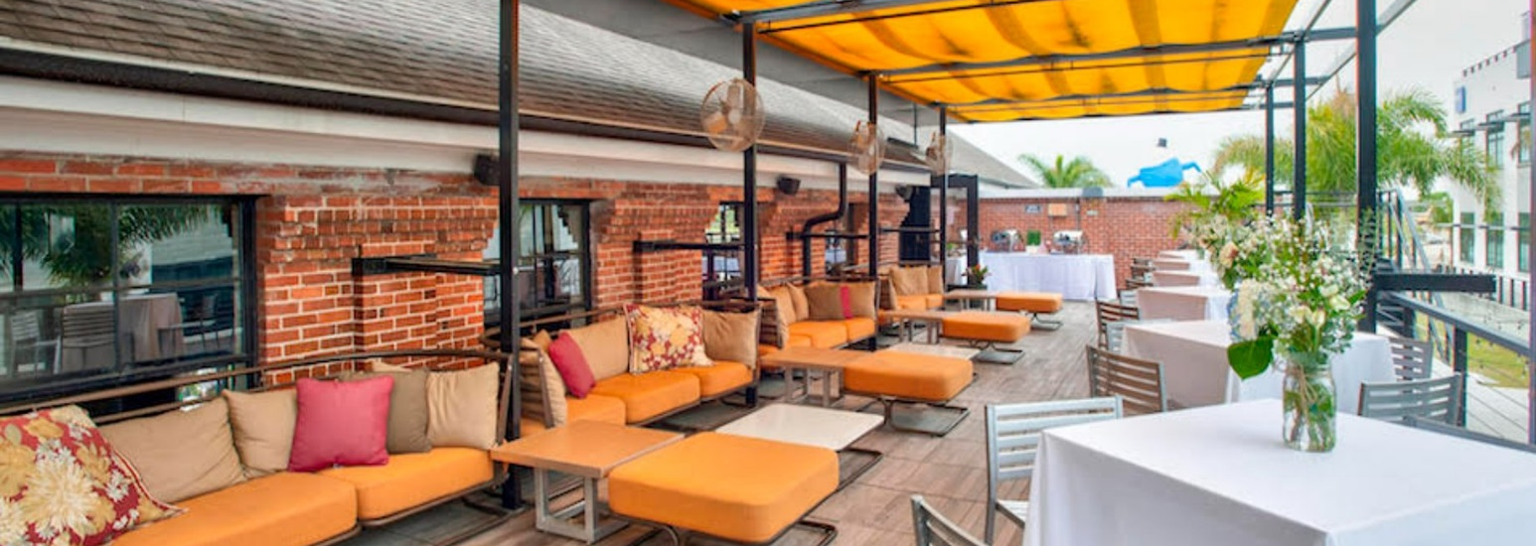 | You are invited
Please join Greenberg Traurig for dinner
Thursday, March 7, 2024
7:00 – 10:00 pm
Ūlëlē
Fireside Rooftop Patio
1810 North Highland Avenue
Tampa, Florida 33603

Join us in this private outdoor rooftop patio for a relaxing dinner and culinary delights focused on hyper-local ingredients and vibrant flavors which you may pair with craft beer selections from the onsite Ūlëlē Spring Brewery.
RSVP by 3/5/24.

 | Greenberg Traurig, PA | Attorneys at Law | www.gtlaw.com

