
Save the date
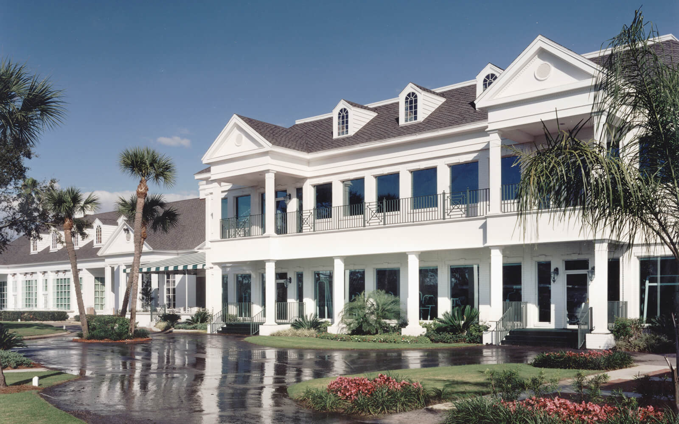
Greenberg Traurig Hosts You
Please join the attorneys from Greenberg Traurig at Palma Ceia Golf & Country Club to enjoy drinks and hors d’oeuvres with in-house counsel from area businesses.
Thursday, April 11, 2024
5:30 – 7:00 p.m.
Palma Ceia Golf & Country Club
1601 South MacDill Avenue
Tampa, FL 33629
Greenberg Traurig, PA | Attorneys at Law | www.gtlaw.com

