Event Program

Location:

Aria Resort & Casino

Juniper Ballroom
3730 S Las Vegas Blvd
Las Vegas, NV 89158

Sponsored by:
Table of Contents
About our Sponsors 3
Program Schedule 4
Thursday, September 30, 2021 4
Friday, October 1, 2021 6
Opening Remarks 7
If you don’t know, now you know A guide to a board’s role in managing (unexpected) risk in the aftermath of the COVID-19 pandemic 8
All about the Green Developments of environmental, social and governance (ESG) issues in the boardroom 10
Keynote Speaker 12
Diversity, inclusion and refreshment The hidden ingredients of successful boardroom governance 13
Buy, sell or hold: What’s a Board to do in today’s M&A environment? 15
“Let’s Talk!” Maximizing the shareholder relationship and the benefits of shareholder engagement 17
Carrots and sticks: Unlocking the power of effective incentive structures in executive and board compensation 20
COVID-19 Protocols 23
Questions or Assistance 23

About our Sponsors
 | Greenberg Traurig, LLP (GT) has approximately 2300 attorneys in 40 locations in the United States, Latin America, Europe, Asia, and the Middle East. GT has been recognized for its philanthropic giving, diversity, and innovation, and is consistently among the largest firms in the U.S. on the Law360 400 list and among the Top 20 on the Am Law Global 100 list. The firm is net carbon neutral with respect to its office energy usage and Mansfield Rule 4.0 Certified. Web: www.gtlaw.com
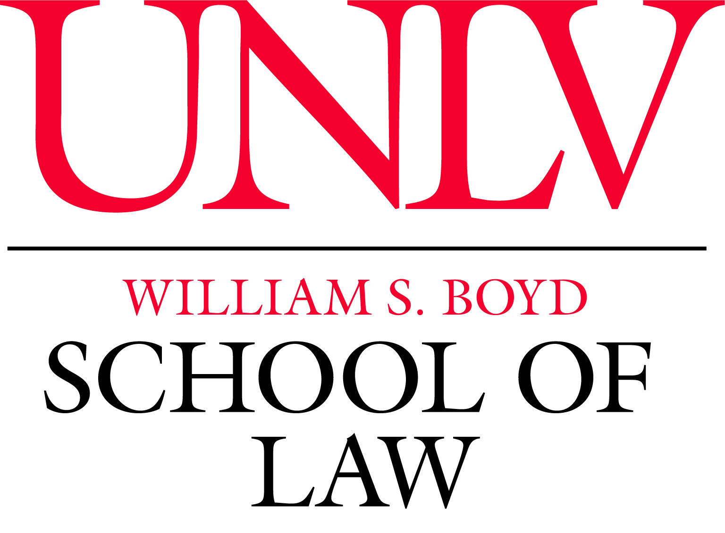 | Established in 1998, the William S. Boyd School of Law at the University of Nevada, Las Vegas has nearly 400 students and offers three juris doctor degree programs: a full-time day program, a part-time day program, and a part-time evening program. The school also offers a Master of Laws (LL.M.) in Gaming Law and Regulation and three dual degree programs: the J.D./MBA, J.D./M.S.W., and J.D./Ph.D. It is fully accredited by the American Bar Association and is a member of the Association of American Law Schools.
 | Aon is a global professional services firm providing a broad range of risk, retirement, and health solutions.
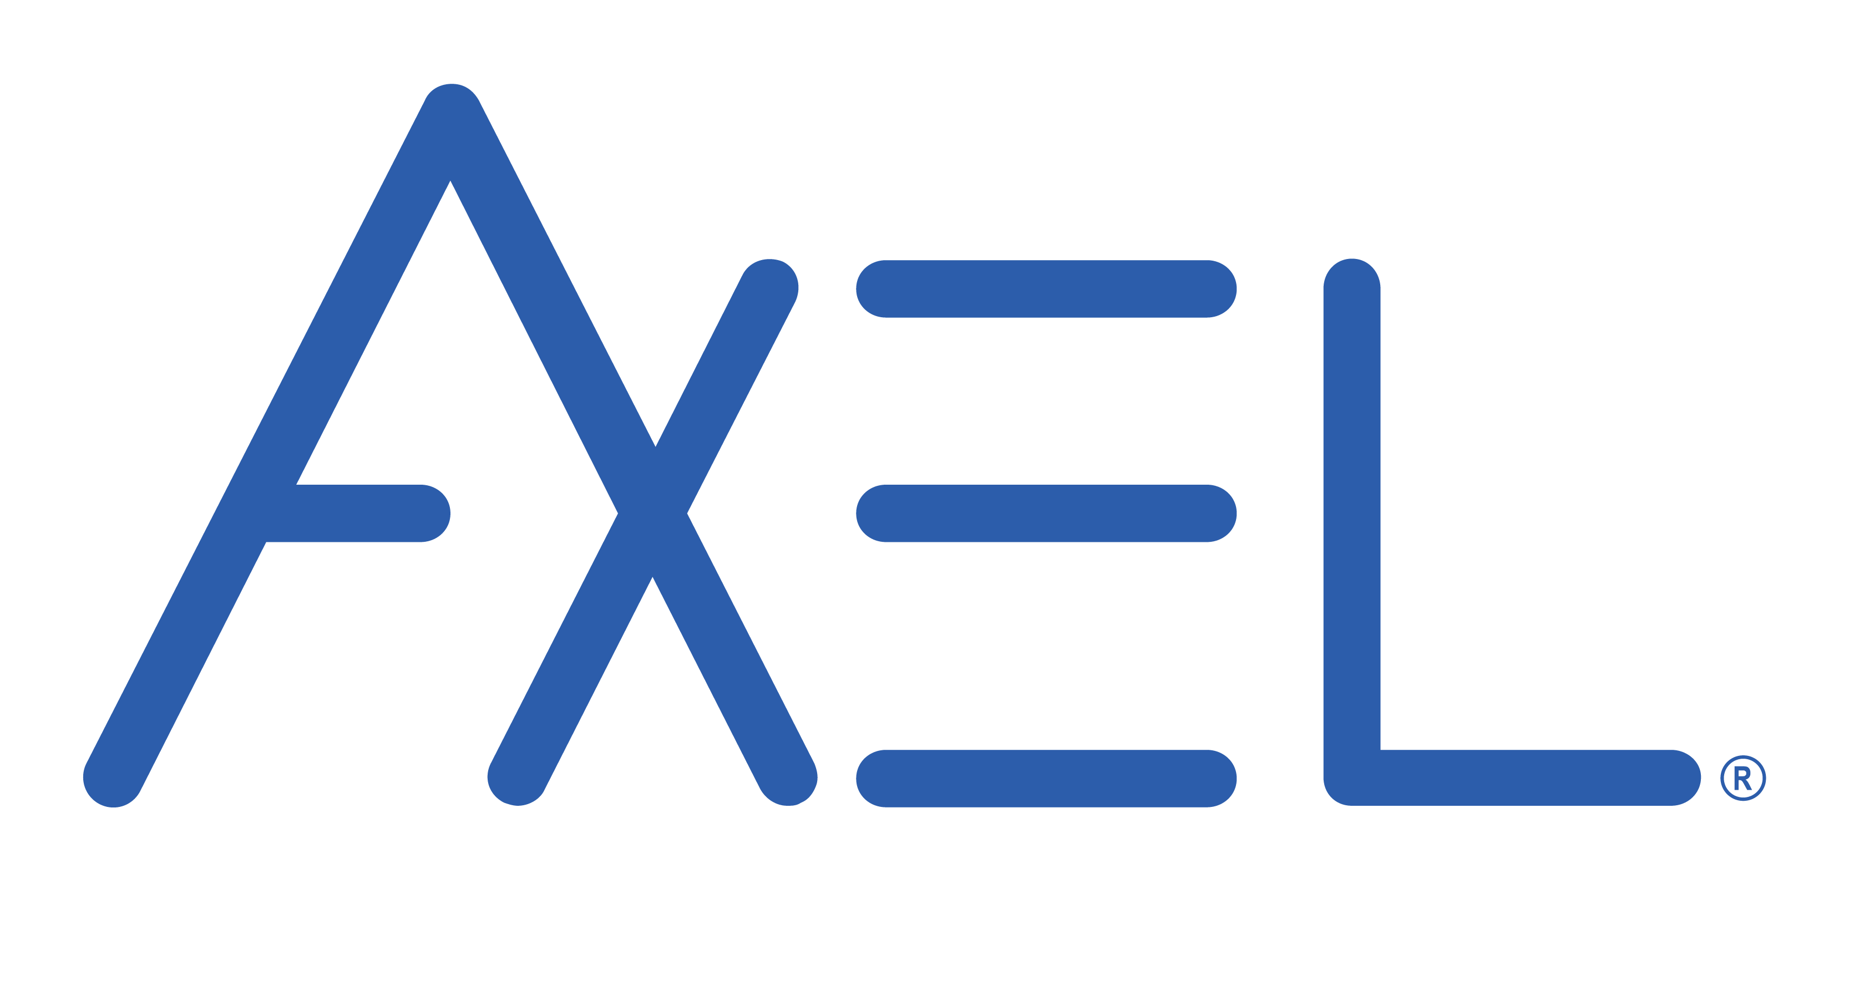 | AXEL is a software company focused on data custody, privacy and security solutions. The company combines patented, blockchain, decentralized and encryption technology in its "AXEL Go" application and affords clients a cyber-resilient way to collect, store, and share files during in-office, hybrid, and remote work situations.
 | DFIN is a global risk and compliance solutions company providing domain expertise, enterprise software, and data analytics for every stage of a clients’ business and investment lifecycles.
 | Joele Frank is a financial communications and investor relations firm providing clients with strategic communications counsel and tactical support across all communications disciplines.

Program Schedule

Thursday, September 30, 2021
8:00 a.m. – 8:45 a.m.
Registration and Continental Breakfast (Location: Juniper 1-3 Rooms)
9:00 a.m. – 9:15 a.m.
Opening Remarks
  - Michael J. Bonner, Managing Shareholder, Greenberg Traurig, LLP, Las Vegas
  - Benjamin P. Edwards, Associate Professor of Law, The UNLV William S. Boyd School of Law
9:15 a.m. – 10:15 a.m.
“If you don’t know, now you know”: A guide to a board’s role in managing (unexpected) risk in the aftermath of the COVID-19 pandemic
  - Michael J. Bonner, Managing Shareholder, Greenberg Traurig, LLP, Las Vegas (Moderator)
  - John Holland, Managing Director and General Counsel, Platinum Equity Advisors, LLC
  - Jordan Rae Kelly, Senior Managing Director, FTI Consulting, Inc. (NYSE: FCN)
  - Nancy Rapoport, Garman Turner Gordon Professor of Law & Affiliate Professor of Business Law and Ethics, The UNLV William S. Boyd School of Law & Lee Business School
10:15 a.m. – 10:25 a.m.
Break
10:25 a.m. – 10:30 a.m.
Sponsor Presentation - Axel
10:30 a.m. – 11:30 a.m.
All about the green: Developments of environmental, social and governance (ESG) issues in the boardroom
  - Rachel Anderson, Professor of Law, The UNLV William S. Boyd School of Law (Moderator)
  - Barbara A. Jones, Co-Managing Shareholder of Greenberg Traurig, LLP’s Los Angeles Office; Co-Chair, Blockchain & Digital Assets Practice
  - Linda Park, Corporate Secretary, VP & Associate General Counsel, Edwards Lifesciences Corporation (NYSE)
  - Jessica Strine, Managing Partner & CEO, Sustainable Governance Partners, LLC
11:30 a.m. – 11:35 a.m.
Sponsor 2 Presentation
11:35 a.m. – 11:45 a.m.
Break
11:45 a.m. – 1:15 p.m.
Lunch & Keynote (Location: Juniper 1-3 Rooms)
  - Robert Jackson, Pierrepont Family Professor of Law, New York University Law; Former SEC Commissioner
1:15 p.m. – 1:25 p.m.
Break
1:25 p.m. – 1:30 p.m.
Sponsor 3 Presentation
1:30 p.m. – 2:30 p.m.
Diversity, inclusion and refreshment: The hidden ingredients of successful boardroom governance
  - Alan I. Annex, Co-Chair of Greenberg Traurig, LLP’s Global Corporate Practice, Miami (Moderator)
  - Thomas Morton, President & Chief Legal Officer, Switch, Inc. (NYSE: SWCH)
  - Radhika Papandreou, Office Managing Partner, Chicago; Sector Leader, Travel, Hospitality & Leisure Practice, Korn Ferry
  - Liane Pelletier, Board Member, Switch, Inc. (NYSE: SWCH); Board Member, Frontdoor, Inc (NASDAQ: FTDR)
2:30 p.m. – 3:30 p.m.
“Buy, sell or hold: What’s a Board to do in today’s M&A environment?”
  - M. Adel Aslani-Far, Shareholder, Greenberg Traurig, LLP, New York (Moderator)
  - John Bailey, Managing Partner, Bailey Kennedy, LLP; Director, Boyd Gaming Corporation (NYSE: BYD)
  - Matthew Jennejohn, Professor of Law, J. Reuben Clark Brigham Young University Law School
3:30 p.m. – 5:00 p.m.
Cocktail Reception (Location: Juniper 4 Room)

Friday, October 1, 2021
9:00 a.m. – 9:30 a.m.
Continental Breakfast (Location: Juniper 1-3 Rooms)
9:30 a.m. – 10:30 a.m.
“Let’s Talk!”: Maximizing the shareholder relationship and the benefits of shareholder engagement
  - Daniel Lee, President & CEO, Full House Resorts, Inc. (NASDAQ: FLL)
  - Christina Sautter, Cynthia Felder Fayard Professorship, Byron R. Kantrow Professorship, and Vinson & Elkins Professorship Professor of Law, Louisiana State University Law
  - Paul Schulman, Managing Director – M&A and Activism Advisory Group, Morrow Sodali
  - Kelly Sullivan, Partner, Joele Frank Wilkinson Brimmer Katcher (Moderator)
10:30 a.m. – 11:30 a.m.
Carrots and sticks: Unlocking the power of effective incentive structures in executive and board compensation
  - Benjamin P. Edwards, Associate Professor of Law, The UNLV William S. Boyd School of Law (Moderator)
  - Richard Nottenburg, Director, Verint Systems Inc (NASDAQ: VRNT) and its spin-out, Cognyte Software Ltd (NASDAQ: CGNT)
  - Richard A. Sirus, Shareholder, Greenberg Traurig, LLP, Chicago
  - Donald Snyder, Director, Western Alliance Bancorporation (NYSE: WAL); and Switch, Inc. (NYSE: SWCH)
  - Pamela Greene, Partner, Human Capital Solutions Practice, Aon plc (NYSE: AON)
11:30 a.m. – 12:00 p.m.
Closing Remarks

Opening Remarks
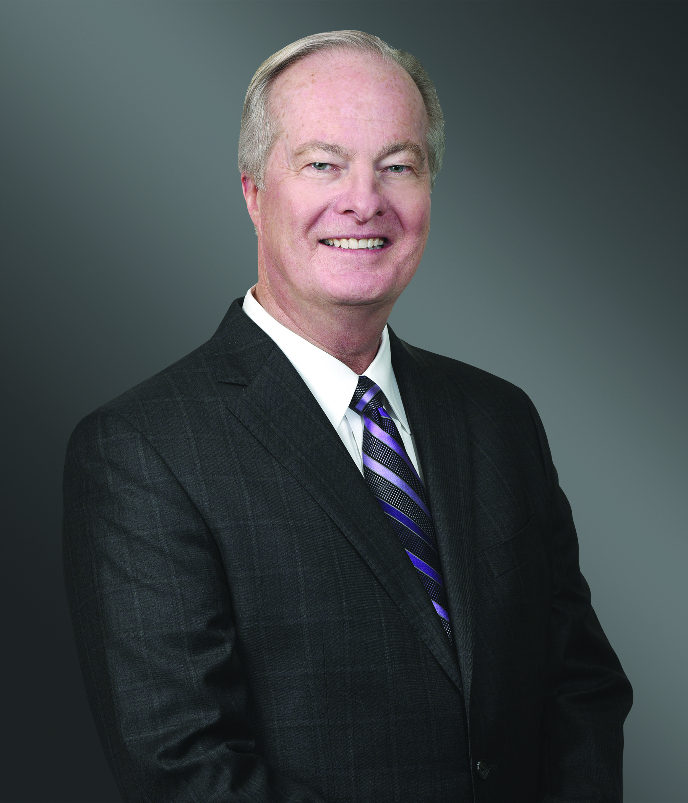 | Michael J. Bonner | Managing Shareholder | Greenberg Traurig, LLP  Michael J. Bonner is Managing Shareholder of Greenberg Traurig’s Las Vegas Office and concentrates his practice in the areas of corporate finance, corporate governance, business transactions, securities and gaming. He represents clients in corporate securities and other business transactions; including acting as lead counsel on mergers and acquisitions, public securities offerings, private placements and a variety of financing, acquisition and restructuring transactions for publicly held and privately held business entities. Mr. Bonner counsels publicly held companies on disclosure obligations under the Securities Exchange Act of 1934, including the preparation of annual reports to stockholders, proxy statements, and annual and quarterly periodic reports to the Securities and Exchange Commission (SEC).  Mr. Bonner acts as outside counsel to several boards of directors and special committees of boards of directors of publicly held and privately held entities.  He also represents publicly held and privately held hotel-casino resort operators, manufacturers, suppliers, lenders and officers, directors, and key employees in transactional, licensing and other approvals before the Nevada State Gaming Control Board and the Nevada Gaming Commission.
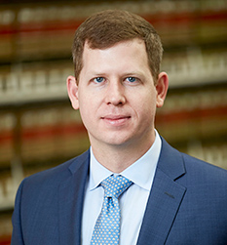 | Benjamin P. Edwards | Director of the Public Policy Clinic and Associate Professor of Law | The UNLV William S. Boyd School of Law  Benjamin P. Edwards joined the faculty of the William S. Boyd School of Law in 2017. He researches and writes about business and securities law, corporate governance, arbitration, and consumer protection issues. Prior to teaching, Professor Edwards practiced as a securities litigator in the New York office of Skadden, Arps, Slate, Meagher & Flom LLP. At Skadden, he represented clients in complex civil litigation, including securities class actions arising out of the Madoff Ponzi scheme and litigation arising out of the 2008 financial crisis.  His writing has appeared in the Northwestern University Law Review, Washington and Lee Law Review, University of California Davis Law Review, Georgia State Law Review, William & Mary Law Review Online, Virginia Law and Business Review, Michigan Business and Entrepreneurial Law Review, Journal of Business and Securities Law, Virginia Journal of Social Policy and the Law, InvestmentNews, Wall Street Journal, Salon, The Hill, The Washington Post, BloombergView, Oxford Business Law Blog, and Columbia Blue Sky Blog. He also writes regularly for the Business Law Professor Blog.  Professor Edwards earned his law degree from Columbia Law School and clerked for Judge Samuel H. Mays, Jr. of the U.S. District Court for the Western District of Tennessee.  Professor Edwards's most recent publications and working papers may be found on the Social Science Research Network.

If you don’t know, now you know
A guide to a board’s role in managing (unexpected) risk in the aftermath of the COVID-19 pandemic
Michael J. Bonner | Managing Shareholder | Greenberg Traurig, LLP

Michael J. Bonner is Managing Shareholder of Greenberg Traurig’s Las Vegas Office and concentrates his practice in the areas of corporate finance, corporate governance, business transactions, securities and gaming. He represents clients in corporate securities and other business transactions; including acting as lead counsel on mergers and acquisitions, public securities offerings, private placements and a variety of financing, acquisition and restructuring transactions for publicly held and privately held business entities. Mr. Bonner counsels publicly held companies on disclosure obligations under the Securities Exchange Act of 1934, including the preparation of annual reports to stockholders, proxy statements, and annual and quarterly periodic reports to the Securities and Exchange Commission (SEC).
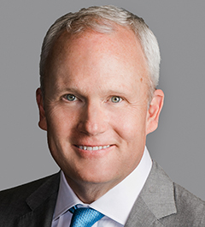 | John Holland | Managing Director and General Counsel | Platinum Equity Advisors, LLC  John Holland is Platinum Equity’s General Counsel, overseeing the legal department and legal affairs for the firm and its portfolio companies.  Prior to joining Platinum Equity in 2020, Mr. Holland was Executive Vice President, Chief Legal and Human Resources Officer at Incora (formerly Wesco Aircraft). Prior to Incora, he served as a Partner at Latham & Watkins LLP. Mr. Holland holds a Bachelor of Arts in Humanities and English from Brigham Young University and a J.D. from Columbia Law School.
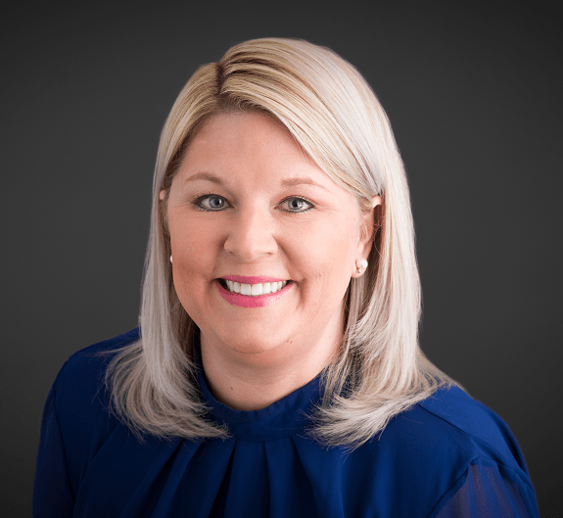 | Jordan Rae Kelly | Senior Managing Director, Head of Americas Cybersecurity | FTI Consulting, Inc.  Jordan Rae Kelly is a Senior Managing Director and the Head of Cybersecurity for the Americas at FTI Consulting. Ms. Kelly has more than 15 years of experience coordinating incident response and managing cyber policy planning. At FTI Consulting, Ms. Kelly advises clients on a broad range of cybersecurity and data privacy matters involving breaches, insider threats, intellectual property, crisis communications, vendor management, compliance, regulation, risk management, and forensic investigations.
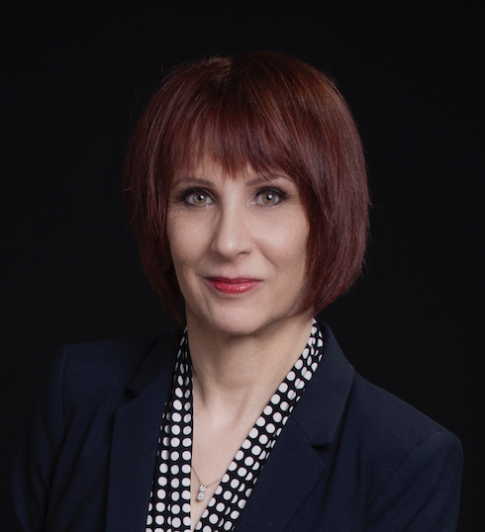 | Nancy B. Rapoport | Garman Turner Gordon Professor of Law & Affiliate Professor of Business Law and Ethics | The UNLV William S. Boyd School of Law & Lee Business School  Nancy B. Rapoport is the Garman Turner Gordon Professor of Law at the William S. Boyd School of Law, University of Nevada, Las Vegas, and an Affiliate Professor of Business Law and Ethics at the Lee Business School at UNLV. After receiving her B.A., summa cum laude, from Rice University in 1982 and her J.D. from Stanford Law School in 1985, she clerked for the Honorable Joseph T. Sneed III of the United States Court of Appeals for the Ninth Circuit and then practiced law (primarily bankruptcy law) with Morrison & Foerster LLP in San Francisco from 1986-1991. Her specialties are bankruptcy ethics, ethics in governance, law firm behavior, and the depiction of lawyers in popular culture. In 2001, she was elected to membership in the American Law Institute, and in 2002, she received a Distinguished Alumna Award from Rice University. She is also a Fellow of the American Bar Foundation and a Fellow of the American College of Bankruptcy. In 2009, the Association of Media and Entertainment Counsel presented her with the Public Service Counsel Award at the 4th Annual Counsel of the Year Awards. In 2017, she received the Commercial Law League of America’s Lawrence P. King Award for Excellence in Bankruptcy, and in 2018, she was one of the recipients of the NAACP Legacy Builder Awards (Las Vegas Branch #1111). She is the Secretary of the Board of Directors of the Mob Museum and a Trustee of Claremont Graduate University.

All about the Green
Developments of environmental, social and governance (ESG) issues in the boardroom
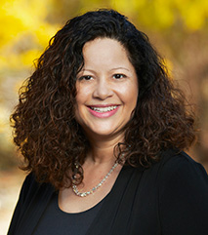 | Rachel J. Anderson | Professor of Law | The UNLV William S. Boyd School of Law  Rachel J. Anderson is currently on a leave of absence to serve as General Counsel, Office of the Attorney General, State of Nevada. Professor Anderson is a tenured Professor of Law at the William S. Boyd School of Law, University of Nevada, Las Vegas. She teaches courses on Business Organizations, Consumer Law, International Business Transactions, International Law, and Diversity Leadership. Before becoming a full-time faculty member at the William S. Boyd School of Law, UNLV in 2007, Professor Anderson worked at Skadden, Arps, Slate, Meagher & Flom LLP (UK) in London, England and MVV Consulting GmbH in Berlin, Germany. She has experience in international development projects and general corporate, mergers and acquisitions, corporate finance and securities matters.
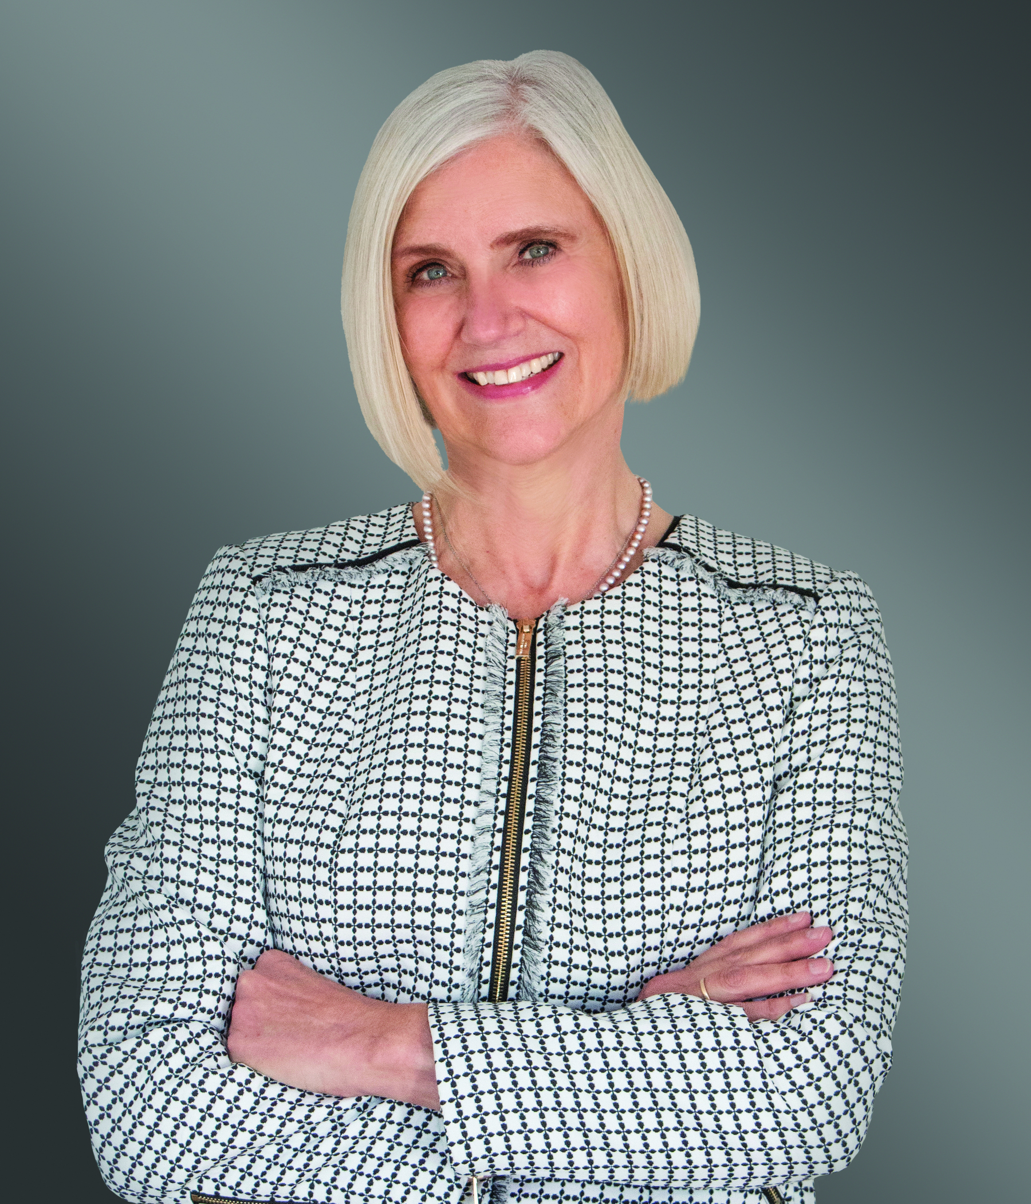 | Barbara A. Jones | Co-Managing Shareholder of Greenberg Traurig LLP’s Los Angeles Office; Co-Chair, Blockchain & Digital Assets Practice | Greenberg Traurig, LLP  Barbara A. Jones is Co-Managing Shareholder of Greenberg Traurig’s Los Angeles office and a member of the firm’s Global Corporate Practice. Barbara serves as Co-Chair of the firm's interdisciplinary Blockchain & Digital Assets Practice. Barbara maintains a diverse corporate and securities law practice across industry groups, emphasizing complex international and domestic transactions, including private and public financings, dual listings, mergers and acquisitions, strategic collaborations and joint ventures, and licensing transactions. She serves as a trusted advisor to public and private company boards of directors on governance matters and complex regulatory reporting and compliance issues. Barbara's clients include financial institutions, private equity and venture capital groups, and public and private companies in emerging technology, life sciences and biotechnology, defense and security, blockchain and digital assets, telecommunications, information technology, energy (traditional and renewable), mining, media, entertainment and sports. Barbara also represents Olympic and professional athletes and sports-related organizations.
 | Linda J. Park | Vice President, Associate General Counsel and Corporate Secretary| Edwards Lifesciences Corporation  Linda J. Park has served as Vice President, Associate General Counsel and Corporate Secretary for Edwards Lifesciences Corporation since October 2017. Prior to joining Edwards, she was Associate General Counsel, Securities, Corporate Governance and Executive Compensation for Western Digital Corporation. Ms. Park spent most of her years in private practice specializing in securities, capital markets and corporate governance matters in New York City at Gibson, Dunn & Crutcher LLP and Latham & Watkins LLP.  Currently, Ms. Park is responsible for maintaining the integrity of Edwards’ governance framework, ensuring compliance with the statutory and regulatory requirements of a public company and counseling and implementing decisions made by the Board of Directors. She acts as an advisor to the company’s Board of Directors and also advises the executive leadership team with respect to securities, corporate governance, sustainability and executive compensation matters. She actively supports Edwards’ Finance team in banking and capital markets transactions, supports the Corporate Development team on mergers, acquisitions and investments, and she is also a member of the company’s Sustainability Council.  Ms. Park holds a bachelor’s degree, with honors, from The Johns Hopkins University and a law degree from Duke University School of Law.
 | Jessica Wirth Strine | Managing Partner and CEO | Sustainable Governance Partners, LLC (SGP)  Jessica Wirth Strine is managing partner and CEO at SGP. She specializes in contentious voting situations, sustainability strategy, fundamental company analysis and engagement & communications strategy. With nearly twenty years of experience in active equity fund management and passive fund stewardship, Jessica has unique insights into the practices of both fundamental active investors and passive governance decision makers. Prior to forming SGP, Jessica was a senior director on the Investment Stewardship team at Vanguard, overseeing proxy voting decision-making and leading engagement with directors and executive team members at public companies across the U.S. While at Vanguard, Jessica also led an interdisciplinary ESG working group, focusing on the research, policy and market implications of environmental, social and governance issues. Prior to serving passive investors in a stewardship capacity, Jessica worked in active equity portfolio management, most recently at BlackRock and previously at Putnam Investments and Wellington Management Company. While on the buy-side, she directed global investments in securities within the energy sector, managed natural resources sector funds and led a team of equity research analysts covering the full spectrum of industries worldwide. In merging her experience as a governance leader and an active equity investor, Jessica sees the significant opportunity to directly empower public companies to drive long term shareholder value by applying a broad and long-term lens to the bottom line

Keynote Speaker
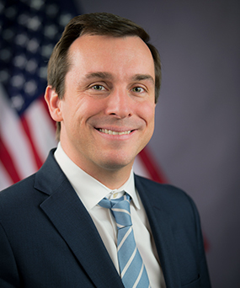 | Robert J. Jackson, Jr. | Pierrepont Family Professor of Law, New York University Law | Former SEC Commissioner  Robert J. Jackson, Jr. is the Pierrepont Family Professor of Law, Co-Director of the Institute for Corporate Governance and Finance, and Director of the Program on Corporate Law and Policy at the New York University School of Law. Among other premier publications, his work has been featured in the Journal of Finance, the Journal of Law and Economics, and the Harvard Law Review.  He was nominated and unanimously confirmed by the U.S. Senate to be Commissioner of the U.S. Securities and Exchange Commission (SEC) in 2017 and served in that role until February 2020. Commissioner Jackson was an outspoken advocate for protecting investors, consistently calling for more transparency in capital markets and championing evidence-driven policymaking. Jackson challenged Silicon Valley insiders on dual-class stock that enables intergenerational transfers of control of America’s largest public companies and called competition economics the “forgotten fourth pillar” of the SEC’s mission. Jackson’s Office helped lead the SEC’s unanimous adoption of a pilot program to study effects of stock-exchange payments on market dynamics.  Jackson’s research has consistently produced bipartisan legislation to address the gaps created by application of securities law to modern markets. His paper identifying significant insider trading before the announcement of significant corporate developments led to legislation to outlaw that trading. Another study identifying how SEC systems gave high-speed traders an advantage over ordinary investors led to bipartisan demands for a level playing field. And Jackson’s calls for an insider-trading law for the 21st century produced a bipartisan bill to close gaps in existing law.  Prior to his nomination to the SEC, Professor Jackson taught at Columbia Law School, where students honored him with the Reese Prize for Excellence in Teaching. Before entering academia, he served as a senior policy advisor at the U.S. Treasury Department during the financial crisis and as deputy to Kenneth Feinberg, Treasury’s Special Master on Executive Compensation. Earlier in his career, Professor Jackson practiced law at Wachtell, Lipton, Rosen & Katz and was an investment banker at Bear, Stearns. Commissioner Jackson holds two undergraduate degrees (one in finance, another in philosophy) from the University of Pennsylvania, an MBA in Finance from the Wharton School of Business, a Master of Public Policy from Harvard’s Kennedy School, and a law degree from the Harvard Law School. He was born in the Bronx, is a lifelong fan of the New York Yankees, and lives in New York with his wife, Bryana.

Diversity, inclusion and refreshment
The hidden ingredients of successful boardroom governance
 | Alan I Annex | Co-Chair of Global Corporate Practice | Greenberg Traurig, LLP  Alan I. Annex is Co-Chair of Greenberg Traurig’s Global Corporate Practice. He leads multi-disciplinary deal teams in a wide variety of large-cap and middle-market domestic and cross-border transactions. Alan has broad experience in corporate and securities matters, and regularly advises public company boards, special committees and executive management regarding their fiduciary duties; corporate governance best practices; and M&A deal strategies, structures, and techniques.  Alan was an architect of the structure for the early Special Purpose Acquisition Companies (SPACs) of the 1990s. He routinely leads 20+ attorney teams whose deals have increased exponentially in number and value over the past year. Under Alan’s leadership, GT leapt from 20th on SPAC Research’s DeSPAC Legal Advisors table for business combinations in 2019 to second in the same table by 2021 (based on closed and pending deals).  Alan recently lead the team of GT attorneys who handled one of the largest SPAC merger transactions ever, United Wholesale Mortgage, with an approximate value of $16 billion.
 | Thomas Morton | President and Chief Legal Officer | Switch, Inc.  Thomas Morton joined Switch in 2008 where he currently serves as the President and Chief Legal Officer. As Switch has grown as an enterprise, Mr. Morton served in several leadership roles within the organization, including several years as Chief Financial Officer and General Counsel through Switch’s IPO in 2017.  Prior to joining Switch, Mr. Morton had a successful career as an intellectual property and M&A attorney from 1997-2008. First with Gray Cary (now DLA Piper) and then Pillsbury Winthrop Shaw Pittman LLP. Mr. Morton received a B.A. in Finance from the University of San Diego and a Juris Doctorate from the University of the Pacific. He also holds a Certificate in International Law from the University of Austria, Salzburg. Mr. Morton has served on the Board of the McClellan Incubator and the Sacramento Area Regional Technology Alliance (SARTA). He also co-founded two software companies (Finish Line and ImageKeeper) the first of which has been sold and the other continues in operation.  Outside of Switch, Mr. Morton serves on the Board of Summit Spirits and Wine and the Board of Trustees for the University of Nevada, Las Vegas. He also actively participates in children’s charities and was one of three founders of Hope Productions, which provides a yearlong education program to assist children’s charities with business fundamentals and achieving success milestones.
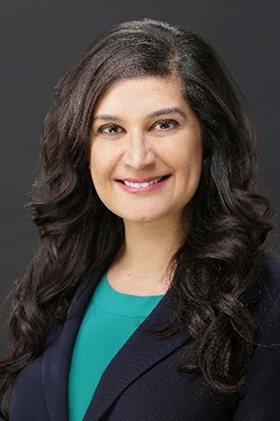 | Radhika Papandreou | Office Managing Partner, Chicago, Sector Leader, Travel, Hospitality & Leisure Practice | Korn Ferry  Radhika Papandreou is Managing Partner of Korn Ferry’s Chicago office and leads Korn Ferry’s North American Travel, Hospitality and Leisure Practice. She joined Korn Ferry from a leading executive search firm, where she was managing director and global head of its Hospitality and Leisure Practice. Ms. Papandreou specializes in C-Suite and Board placements and has managed large scale client projects including bankruptcies and turnarounds.  Previously, Ms. Papandreou had an eighteen-year career in corporate banking, most recently as managing director and head of the Consumer and Healthcare Practice for Lloyds Bank North America. Prior to that she was a senior banker at BBVA. She began her banking career at Citigroup, working within its corporate and investment banking units in both New York and London.  Ms. Papandreou speaks frequently at industry conferences and contributes to industry publications primarily around Diversity, Equity and Inclusion. Ms. Papandreou earned a Bachelor of Arts Degree with a dual major in International Affairs & Economics from the Johns Hopkins University, and later a Master of Business Administration with an emphasis in finance from New York University’s Stern School of Business. Ms. Papandreou is a member of the Arogya World Board of Directors, a U.S. based non-profit organization striving to reduce the global impact of chronic non-communicable diseases (NCDs).
 | Liane Pelletier | Board Member |Switch (NYSE), Frontdoor (Nasdaq), Expeditors International (Nasdaq), and ATN International (ATNI)  Liane Pelletier is a former public company CEO and Chairman, with a 25 year operating career in telecom. She is currently a full-time independent corporate director across a variety of industries. She has occupied every seat at the corporate boardroom table over the last 18 years, from public company CEO, Executive Chairman, nonexecutive Chairman, Lead Independent Director, and either Chairman or member of Audit, Risk, Compensation and Nominating and Governance Committees. She brings deep expertise in cyber security oversight, business model transformation, CEO succession, shareholder engagement, operating in highly regulated industries, and operating across the globe. She is a NACD Board Leadership Fellow and invests significantly in continuous education of board and technology topics. She has earned the professional certificate in Cybersecurity Oversight from Carnegie Mellon’s Software Engineering Institute/NACD. Her current board roles include: member of the Nominating and Corporate Governance Committee at Switch (NYSE: SWCH); Chairman of the Nominating and Corporate Governance Committee and member of the Audit Committee at Expeditors International (Nasdaq: EXPD); Lead Independent Director and member of the Compensation Committee at ATN International (Nasdaq: ATNI); and member of the Audit and Compensation Committees at Frontdoor (Nasdaq: FTDR).

Buy, sell or hold:
What’s a Board to do in today’s M&A environment?

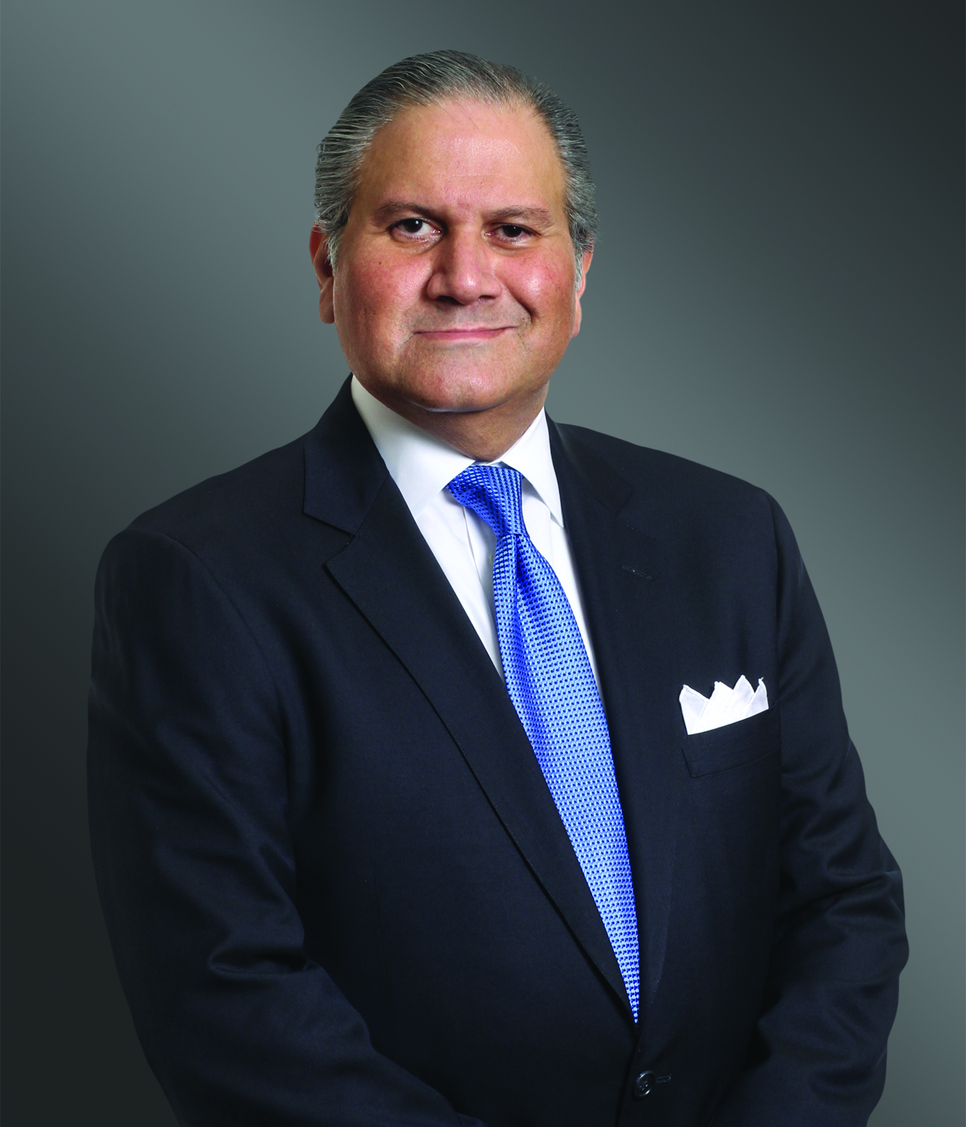 | M. Adel Aslani-Far | Shareholder | Greenberg Traurig, LLP  Adel Aslani-Far focuses his practice on cross-border and domestic public company mergers and acquisitions (including take-private transactions), corporate governance, and shareholder activism and takeover defense. He counsels large multinational corporations and other buyers and sellers on negotiated and hostile public M&A and take-private transactions, private investments in public entities (PIPEs), as well as a broad range of private acquisitions and joint ventures around the world, in a broad range of industries including, among others, bio-pharmaceuticals, life sciences and medical devices; technology, media and telecommunications; energy and financial services. He also regularly counsels public company boards, board committees, and senior management on corporate governance and strategic planning, including shareholder activism and takeover defense preparedness and in defending against proxy contests and negotiating settlements with many of the most prominent activist funds. In addition, Mr. Aslani-Far has deep experience advising special committees of boards of directors in conflict of interest transactions.
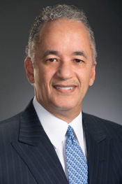 | John R. Bailey | Managing Partner | Bailey Kennedy  For over 35 years, John R. Bailey’s trial experience has focused on commercial corporate litigation, healthcare law, and gaming law. He continues to focus in these areas. In addition, Mr. Bailey has on numerous occasions served as a private mediator for pending litigation matters.  After sixteen years with Nevada’s largest law firm, Mr. Bailey elected to form his own firm, which has now grown to become Bailey Kennedy. His clients include many of Nevada’s largest healthcare providers, Nevada businesses, and travel and tourism leaders. Well respected by his colleagues, Mr. Bailey has been recommended to the Bush Administration for a Judgeship on the U.S. Court of Appeals for the Ninth Circuit by Senators John Ensign and Harry Reid. Mr. Bailey also has the following experience with publicly traded corporations: Boyd Gaming Corporation (NYSE: BYD): Board of Directors (2015-present); SHFL entertainment, Inc. (NASDAQ Global Select Market: SHFL): Board of Directors (2008-2013).
 | Matthew Jennejohn | Professor of Law | J. Reuben Clark Brigham Young University Law School  Matthew Jennejohn is a Professor of Law at BYU Law School and a graduate of Columbia Law School. In autumn 2019, he was the Justin W. D'Atri Visiting Professor of Law, Business & Society at Columbia Law School. Prior to joining academia, he practiced for five years at Shearman & Sterling LLP in New York and was a law clerk for (then) Vice Chancellor Leo Strine of the Delaware Court of Chancery.

“Let’s Talk!”
Maximizing the shareholder relationship and the benefits of shareholder engagement
 | Daniel R. Lee | Director, President and Chief Executive Officer | Full House Resorts, Inc.  Daniel R. Lee joined the Board of Directors of Full House Resorts and he was appointed as President and Chief Executive Officer in November 2014. Before joining Full House Resorts, Mr. Lee was the Managing Partner of Creative Casinos from September 2010 through December 2014. He was previously Chairman and Chief Executive Officer of Pinnacle Entertainment from 2002 to 2009. In the 1990s, he was Chief Financial Officer, Treasurer, and Sr. Vice President of Finance and Development at Mirage Resorts, reporting to Mirage CEO Steve Wynn. During the 1980s, Mr. Lee was a securities analyst for Drexel Burnham Lambert and CS First Boston, specializing in the lodging and gaming industries. He serves as an independent director of Associated Capital and previously served as an independent director of LICT Corporation. While working as a securities analyst, he was a Chartered Financial Analyst. Mr. Lee earned his MBA in finance and a B.S. degree in Hotel Administration, both from Cornell University.
 | Christina M. Sautter | Cynthia Felder Fayard Professor of Law, Byron R. Kantrow Professor of Law, and Vinson & Elkins Professor of Law | Louisiana State University  Christina M. Sautter specializes in corporate governance matters, particularly as they relate to investors’ engagement and to mergers and acquisitions. She holds the Cynthia Felder Fayard, the Byron R. Kantrow, and the Vinson & Elkins Professorships of Law at Louisiana State University Paul M. Hebert Law Center. Her current strand of scholarship focuses on new generations of investors’ power to transform corporate governance, analyzing the role of technology and online communications as well as of generational features and affinities. Her co-authored article, Corporate Governance Gaming: The Power of Retail Investors, forthcoming in the Nevada Law Journal, addresses the potential of new generations of retail investors to change corporate governance. Professor Sautter also has extensively written on M&A. She is the co-author of MERGERS AND ACQUISITIONS LAW, a hornbook published by West Academic Publishing. Her M&A scholarship focuses on the sale process of publicly traded companies and the intersection of fiduciary duties and deal terms. Prior to entering academia, she practiced in the Mergers & Acquisitions Group in the New York City offices of Shearman & Sterling LLP, where she represented companies from a variety of industries in multi-million- and billion-dollar multinational M&A deals on both the sell side and buy side. She also provided on-going corporate governance advice to boards of directors. Prior to joining Shearman & Sterling, she clerked for the late Honorable H. Emory Widener, Jr. of the United States Court of Appeals for the Fourth Circuit.
 | Paul Schulman | Managing Director - M&A and Activism Advisory Group | Morrow Sodali  Paul Schulman joined Morrow Sodali in January 2020 with three decades of experience providing strategic counsel to boards of directors and executives of U.S. and international companies facing complex and contentious proxy, governance and shareholder challenges. Paul has developed a reputation as a leading advisor in friendly and contested M&A, privatizations, hostile takeovers, proxy contests, shareholder activism defense and complex corporate governance issues. Prior to joining Morrow Sodali, Paul spent 10 years in senior management at proxy solicitation firm MacKenzie Partners.  In addition to working with clients on contentious shareholder votes related to board, compensation and ESG issues, Paul has led and worked on over 250 mergers, tender offers, and contested or activism situations over his career. His experience in activism situations and proxy contests spans a broad range of industries and market cap companies, including Procter & Gamble/Trian; AT&T/Elliott Management; PDC Energy/Kimmeridge; Ironwood Pharmaceuticals/Sarissa; Sandridge Energy/Icahn; Texas Pacific Land/Softvest; Casella Waste/JCP; Consolidated-Tomoka/Wintergreen Advisors; Boingo Wireless/Ides Capital and Caesarstone/Kibbutz S’dot Yam directors.  His experience in contested M&A situations include Rowan/Ensco; Carrizo Oil & Gas/Callon Petroleum; Rice Energy/EQT; Kindred Healthcare/Humana, TPG and Welsh Carson; BW LPG/Dorian LPG; Resolute Energy/Cimarex; and Denbury Resources/Penn Virginia.  In addition to his work in the U.S., Paul has handled over 20 assignments for companies based in China over the past few years, including contested privatizations at Sinovac, Yongye International and Harbin Electric. Paul received a B.S. in Chemical Engineering from Tulane University.
 | Kelly Sullivan | Partner | Joele Frank  Kelly counsels clients on a variety of high-profile, high-stakes issues. Her background in politics continues to shape her focus of helping clients “win” at key decision points. Many of these clients are in regulated industries, such as the energy, media, airline, healthcare, gaming and telecommunications sectors, where a premium is placed on the intersection of sophisticated communications with political and regulatory processes.  At both the federal and state levels, companies face increasing regulatory reviews and political interests. Understanding these constituencies is increasingly important to our clients. Kelly advises EDF, the largest nuclear operator in the world, on its U.S. presence, beginning with the company’s investment in Constellation Energy. She worked on the merger of SIRIUS and XM Satellite Radio and continues to advise the company today.  Kelly has worked with a number of clients on an ongoing basis to develop and execute their investor and communications programs, included FedEx, Chiquita, Monster Worldwide, American Tower, Capella Education, USEC, Hawaiian Electric Industries, ADM, TIAA-CREF and Savient Pharmaceuticals.  Prior to joining Joele Frank in 2006, Kelly was at the public affairs firm Chlopak, Leonard, Schechter & Associates. She also served as a spokesperson for the National Endowment for the Arts under Chairwoman Jane Alexander and began her career as press secretary to Congresswoman Louise M. Slaughter (D-NY). Kelly graduated from Georgetown University with a B.A. in American Government. She serves as trustee on the Foundation Board of Kingsborough Community College.

Carrots and sticks:
Unlocking the power of effective incentive structures in executive and board compensation
Benjamin P. Edwards | Director of the Public Policy Clinic and Associate Professor of Law | The UNLV William S. Boyd School of Law

Benjamin P. Edwards joined the faculty of the William S. Boyd School of Law in 2017. He researches and writes about business and securities law, corporate governance, arbitration, and consumer protection issues. Prior to teaching, Professor Edwards practiced as a securities litigator in the New York office of Skadden, Arps, Slate, Meagher & Flom LLP. At Skadden, he represented clients in complex civil litigation, including securities class actions arising out of the Madoff Ponzi scheme and litigation arising out of the 2008 financial crisis.

His writing has appeared in the Northwestern University Law Review, Washington and Lee Law Review, University of California Davis Law Review, Georgia State Law Review, William & Mary Law Review Online, Virginia Law and Business Review, Michigan Business and Entrepreneurial Law Review, Journal of Business and Securities Law, Virginia Journal of Social Policy and the Law, InvestmentNews, Wall Street Journal, Salon, The Hill, The Washington Post, BloombergView, Oxford Business Law Blog, and Columbia Blue Sky Blog. He also writes regularly for the Business Law Professor Blog.

Professor Edwards earned his law degree from Columbia Law School and clerked for Judge Samuel H. Mays, Jr. of the U.S. District Court for the Western District of Tennessee.

Professor Edwards's most recent publications and working papers may be found on the Social Science Research Network.
 | Dr. Richard Nottenburg | Director | Cognyte Software Ltd.  Dr. Richard Nottenburg serves as a member of the Board of Directors of Cognyte Software. Additionally, Dr. Nottenburg has served as a director of Verint for more than seven years. Dr. Nottenburg is currently an Executive Partner at OceanSoundPartners LP, a private equity firm, and an investor in various early stage technology companies. Previously, Dr. Nottenburg served as President and Chief Executive Officer and a member of the board of directors of Sonus Networks, Inc. from 2008 through 2010. From 2004 until 2008, Dr. Nottenburg was an officer with Motorola, Inc., ultimately serving as its Executive Vice President, Chief Strategy Officer, and Chief Technology Officer. Dr. Nottenburg is currently a member of the board of directors of Sequans Communications S.A., where he serves as a member of the compensation committee and the audit committee. Dr. Nottenburg previously served on the board of directors of PMC-Sierra Inc., Aeroflex Holding Corp., Anaren, Inc., Comverse Technology, Inc., and Violin Memory, Inc.
 | Richard A. Sirus | Shareholder | Greenberg Traurig, LLP  Richard A. Sirus focuses his practice on corporate, transactional, tax, employee benefits, executive compensation and employment law matters. He represents clients ranging from publicly traded companies to Taft-Hartley Benefit Funds, including sole proprietorships and executives, providing counsel on general corporate, planning and fiduciary matters, with broad experience in the design, preparation, implementation and administration of retirement plans, employee stock ownership plans (ESOPs), health plans, executive compensation arrangements and fringe benefit programs. He consults regularly with clients regarding fiduciary responsibility and liability matters. He also represents and consults with executives in the assessment, negotiation and preparation of employment arrangements and agreements, including compensation and bonus packages, option and equity arrangements, benefits programs and termination arrangements.  Rich works with taxable and tax-exempt organizations, including consultation regarding multiple and multiemployer plan matters. He has represented clients before the Internal Revenue Service, the U.S. Department of Labor, and the Pension Benefit Guaranty Corporation. He has also served as an expert witness on fiduciary liability and claims issues.
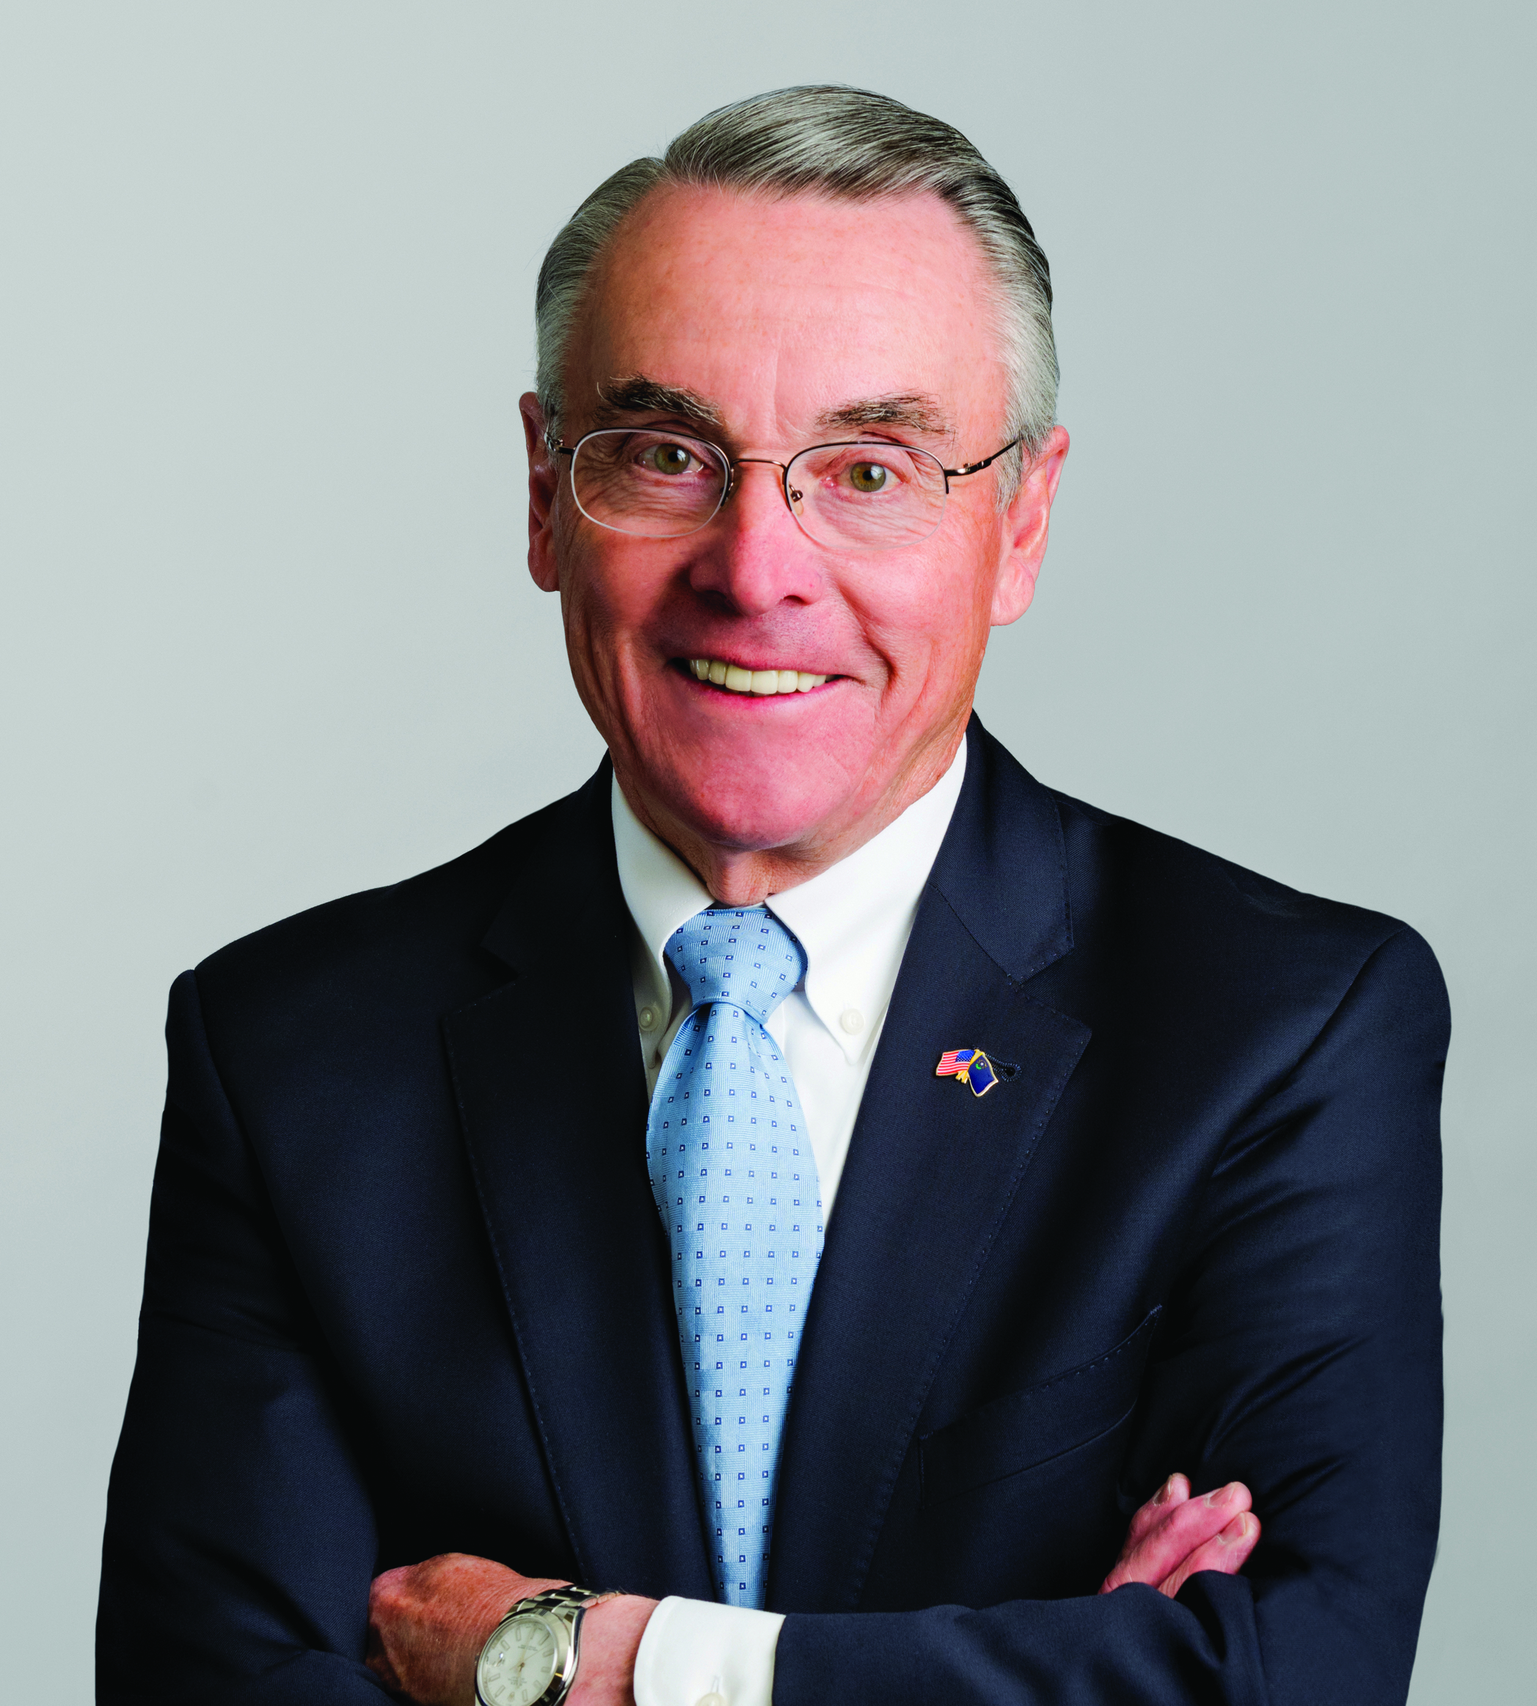 | Donald D. Snyder | Director | Western Alliance Bancorporation (NYSE); and Switch, Inc. (NYSE)  Donald D. Snyder has had a diverse and successful professional career in banking, gaming, hospitality, and higher education. This includes service as Chairman & CEO of First Interstate Bank of Nevada (now Wells Fargo), President & Board Member of Boyd Gaming Corporation and President of the University of Nevada, Las Vegas (UNLV).  He currently sits on the Boards of Directors for two NYSE-listed companies (Western Alliance Bancorporation and Switch, Inc.). Including his current board service, Don has served on the boards of seven public companies and several private and subsidiary company boards.  His active involvement with the community has involved service on several non-profit boards, including the chairmanship of several of those boards and commissions. He has been honored for his community leadership on numerous occasions during his more than 34 years in Nevada.  Don and his wife, Dee, have been married for 50 years. They have three adult children and three grandchildren. Don has also recently completed an autobiography, “Taking the Lead”, with co-author Jack Sheehan.
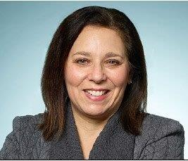 | Pamela Greene | Partner, Human Capital Solutions Practice | Aon plc  Pamela Greene is a Partner on the Corporate Governance team in Aon’s Human Capital Solutions Practice supporting Aon clients globally. Pam has over 30 years of experience providing corporate governance and securities law advice as well as legal and tax advice in executive and equity compensation matters. Pam provides corporate governance, equity compensation and executive compensation consulting to companies, boards and their committees on a wide range of matters and assists clients in understanding and assessing their potential exposure under the multitude of corporate governance and executive compensation policies and guidelines established by regulators, proxy advisory firms and institutional shareholders. Prior to joining Aon, Pam was a partner at an AmLaw 100 law firm providing corporate, securities, and executive compensation advice.

COVID-19 Protocols

Local Las Vegas and State of Nevada COVID-19 health department guidelines and the Aria Resort & Casino require individuals, regardless of COVID-19 vaccination status, to wear face masks when indoors in public spaces. Masks may be temporarily removed to eat or drink. Please be mindful of social distancing guidelines and recommendations while attending the 2021 Summit for Corporate Governance.

Questions or Assistance

If you have any questions or need assistance during the conference, please contact either:
Haben Tesfai  Senior Marketing Manager  Greenberg Traurig, LLP  tesfaih@gtlaw.com  (310) 404-1360 | Melody Liu  Senior Marketing Coordinator  Greenberg Traurig, LLP  lium@gtlaw.com  (626) 639-8805

