Greenberg Traurig Reception Honoring New Jersey Federal and State Appellate Court Law Clerks

Tuesday, November 13, 2019

We look forward to meeting you at our upcoming reception. The following attorneys plan to attend from Greenberg Traurig:


Philip Sellinger, GT NJ Co-Managing Shareholder

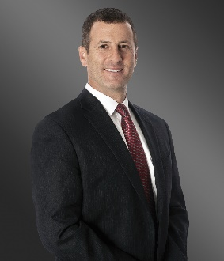
David Jay, GT NJ Co-Managing Shareholder

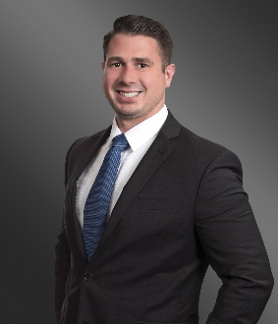
Matthew Bruno

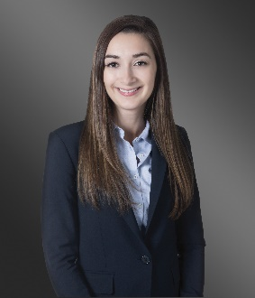
Danielle Gonnella
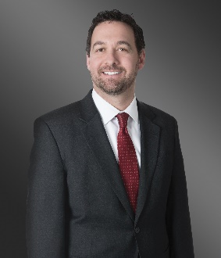
Jason Kislin

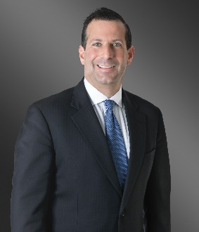
Ian Marx

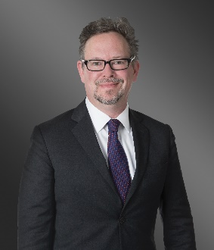
Ted McEvoy

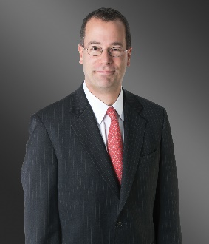
Louis Smith

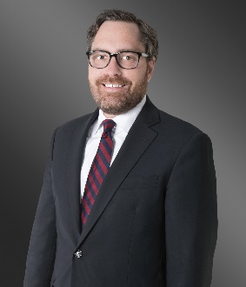
Aaron Van Nostrand

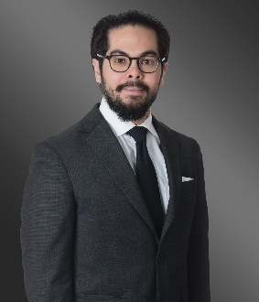
Eric Wong

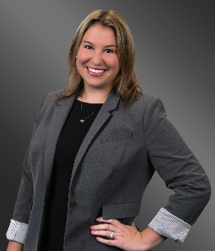
Rebecca Zisek

We invite you to learn more about Greenberg Traurig:

Resources:

- About Greenberg Traurig
  - Commitment to Diversity, Inclusion & Equality
  - GT At A Glance
  - New Jersey Office
  - Women’s Initiative
  - Recent Press
- Select Capabilities
  - Litigation
  - Class Action Litigation
  - Intellectual Property & Technology
  - Labor & Employment

Additional Materials
- Greenberg Traurig Blogs
- Follow Greenberg Traurig on Social Media

